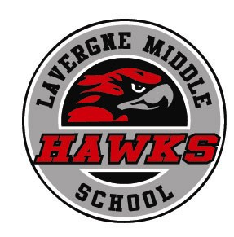
Mr. Cary Holman, Principal
Mr. Richard Reed, Assistant Principal
Ms. Tiffany Copeland, Assistant Principal
“Soaring With Purpose”

382 Stones River Road
LaVergne, TN 37086
615.904.3877 phone
615.904.3878 fax

Opportunity Lab Permission Form

Mission Statement: The mission of LaVergne Middle School is to empower all students to achieve excellence in learning, social responsibility and self-worth and to improve in these each academic year.

Ultimate Goal: To see students perform best on their first attempt on any assignment, project, or assessment, when appropriate study techniques, practices, and efforts have been best utilized.

Rationale: Not all students will master the standards/skills the first time around. As a result, students must take ownership of their actions to reflect on practices and seek to complete review exercises before a second attempt (only once) is granted. This policy provides for additional time and support, parental involvement and student choice.
Please Note:
Retake=Assessments Only/4 day window
Re-do=Failed Assignments/2 day window

Parent/Guardian Acknowledgement:

I acknowledge that I have seen my child’s graded assignment/assessment. _____ (initial)

I am aware that my child did not perform well on the assignment/assessment. _______ (initial)

Student has completed two additional activities in preparation for the re-do/re-take assignment/assessment. _________________________ (Teacher Name-PRINT)

------------------------------------------------------------------------------------------------------------

My child has my permission to attend the morning/afternoon Opportunity Lab.

__________________________________ _____________________
Student Name Reserved “O Lab” Date

__________________________________ ________ (____)_____-______
Parent/Guardian Signature Date Parent Contact #

