Watch:
https://www.youtube.com/watch?v=zK7Ckmxxqds

Introduction
Look at the gray fuzz growing on the bread in Figure below. It’s a type of fungus. It looks gross and it spoils the bread. But fungi like this actually play important roles in many ecosystems. There are also many human uses of fungi, which you’ll learn when you read this lesson.
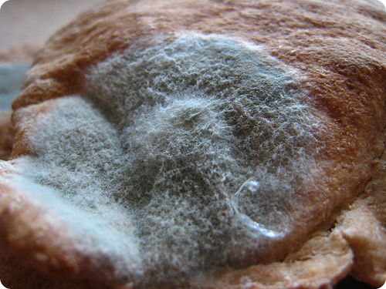
The fuzzy growth on this bread is a fungus.

What Are Fungi?
Fungi (fungus, singular) are relatively simple eukaryotic organisms. They are placed in their own kingdom, the Fungus Kingdom. Most fungi are multicellular organisms. These fungi are called molds. However, some fungi exist as single cells. These fungi are called yeasts. You can see examples of different types of fungi in Figure below.
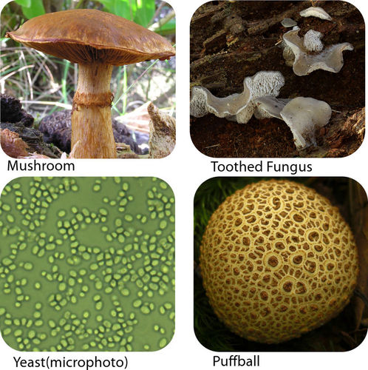

Classification and Evolution of Fungi
For a long time, scientists classified fungi as members of the Plant Kingdom. Fungi share several obvious traits with plants. For example, both fungi and plants lack the ability to move. Both grow in soil, and both have cell walls. Some fungi even look like plants.

Fungi Classification
Today, fungi are no longer classified as plants. We now know that they have important traits that set them apart from plants. That’s why they are placed in their own kingdom. How do fungi differ from plants?
- The cell walls of fungi are made of chitin. Chitin is a tough carbohydrate that also makes up the outer skeleton of insects. The cell walls of plants are made of cellulose.
- Fungi are heterotrophs that absorb food from other organisms. Plants are autotrophs that make their own food.
The Fungus Kingdom is large and diverse. It may contain more than a million species. However, fewer than 100,000 species of fungi have been identified.

