Watch:
https://www.youtube.com/watch?v=ORB866QSGv8

Introduction
The rod-shaped organisms in Figure below are bacteria called Salmonella. Bacteria (bacterium, singular) are prokaryotes in the Bacteria Domain. The word Salmonella may sound familiar. That's because Salmonella is a common cause of food poisoning. Many other types of bacteria also cause human diseases. But not all bacteria are harmful to people. In fact, we could not survive without many of the trillions of bacteria that live in or on the human body. You'll learn why when you read this lesson.
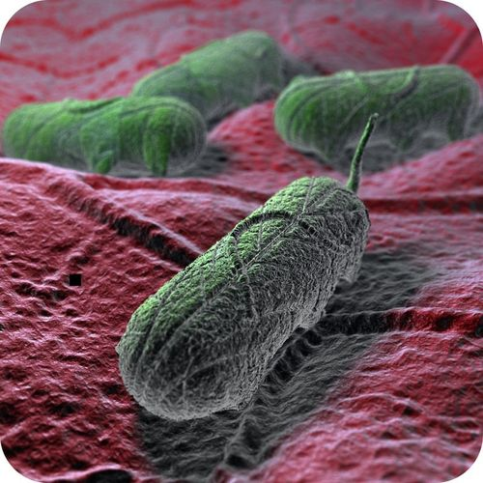
Salmonella bacteria

Counting Bacteria
Bacteria are the most abundant living things on Earth. They live in almost all environments. They are found in the air, ocean, soil, and intestines of animals. They are even found in rocks deep below Earth's surface. Any surface that has not been sterilized is likely to be covered with bacteria. The total number of bacteria in the world is amazing. It's estimated to be about 5 million trillion trillion. If you write that number in digits, it has 30 zeroes!

Classifying Bacteria
Bacteria are the most diverse organisms on Earth. Thousands of species of bacteria have been discovered. Many more are thought to exist. The known species are classified on the basis of various traits. For example, they may be classified by the shape of their cells. They may also be classified by how they react to a dye called Gram stain.

Classifying Bacteria by Shape
Bacteria come in several different shapes. The different shapes can be seen by examining bacteria under a light microscope. Therefore, it's relatively easy to classify them by shape. There are three types of bacteria based on shape:
- bacilli (bacillus, singular), or rod shaped.
- cocci (coccus, singular), or sphere shaped.
- spirilli (spirillus, singular), or spiral shaped.
You can see a common example of each type of bacteria in Figure below.
