Watch:
https://www.youtube.com/watch?v=L6anmd7DnYw

Introduction
There is great variation among species that are called animals. You can see some of the variation in Figure below. Despite this variation, there are a number of traits that are shared by all animals. What traits do all animals share? Read on to find out.
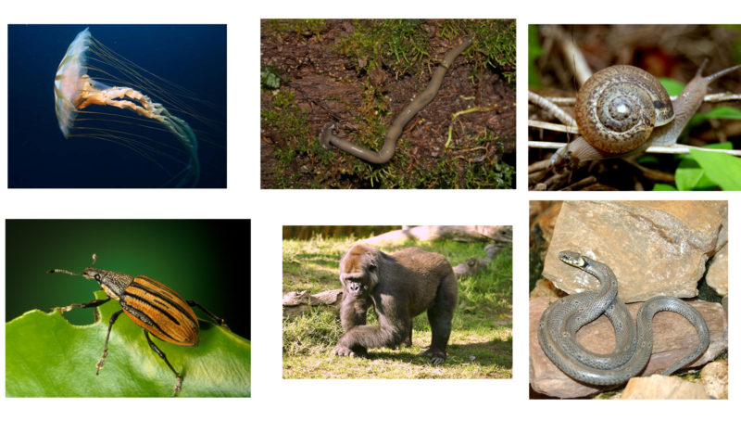
Diversity of the Animal Kingdom: (left to right) jellyfish, worm, snail, beetle, gorilla, and snake.

Basic Animal Traits
Animals are multicellular eukaryotes in the Animal Kingdom. All animals are heterotrophs. They eat other living things because they can’t make their own food. All animals also have specialized cells that can do different jobs. Most animals have higher levels of organization as well. They may have specialized tissues, organs, and even organ systems. Having higher levels of organization allows animals to perform many complex functions. For a visual introduction to what makes a living thing an animal, watch this short video: https://www.youtube.com/watch?v=DXPhJUHooP8.

Specialized Cells
Like the cells of all eukaryotes, animal cells have a nucleus and other membrane-bound organelles. Unlike the cells of eukaryotes in the Plant and Fungus Kingdoms, animal cells lack a cell wall. This gives animal cells flexibility. It lets them take on different shapes. This in turn allows them to become specialized for particular jobs.
The human nerve cell in Figure below is a good example of a specialized animal cell. Its shape suits it for its function of sending nerve signals to other cells. A nerve cell couldn’t take this shape if it were surrounded by a rigid cell wall.
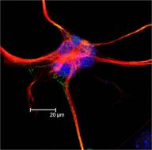
Human nerve cell

What Animals Can Do
With their specialized cells and higher levels of organization, animals can do several things that other eukaryotes cannot.
- Animals can detect and quickly respond to a variety of stimuli. They have specialized nerve cells that can detect light, sound, touch, or other stimuli. Most animals also have a nervous system that can direct the body to respond to the stimuli.
- All animals can move, at least during some stage of their life cycle. Specialized muscle and nerve tissues work together to allow movement. Being able to move lets animals actively search for food and mates. It also helps them escape from predators and other dangers.
- Virtually all animals have internal digestion of food. Animals consume other organisms and may use special tissues and organs to digest them. (Other heterotrophs, such as fungi, absorb nutrients directly from the environment.)

